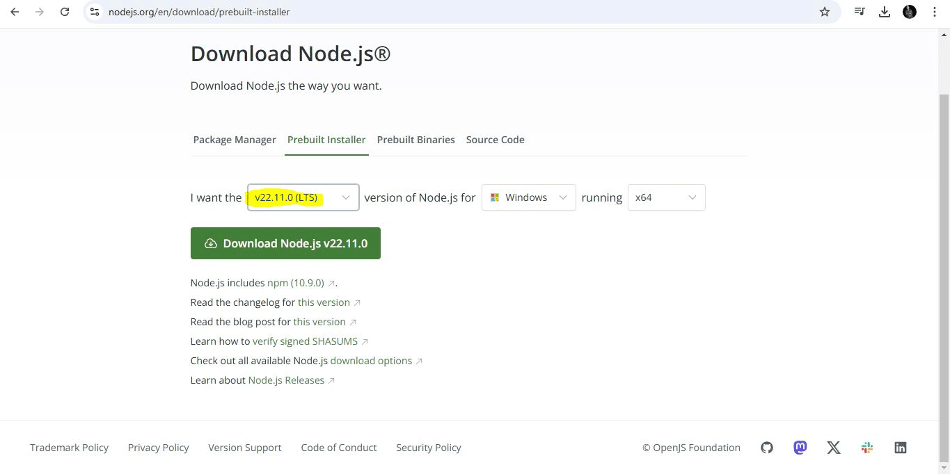

LTS Version Selection

**Installation Guide for Application using React Native expo**

Download Node.js from the official site. Select the LTS version suitable for your operating system.

Ensure your system meets the Node.js requirements.

Launch Node.js and test the shell to verify the installation.

Use Chocolaty for easy installation if needed.

Proceed through the Node.js installer screens.

**Node.js Installation**

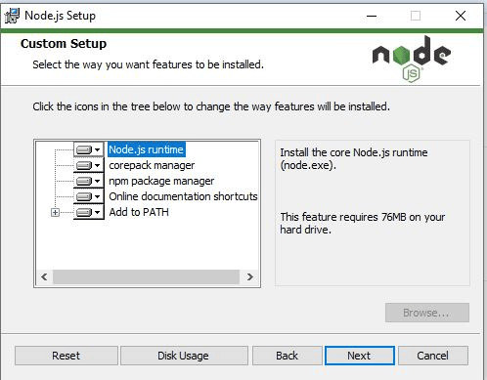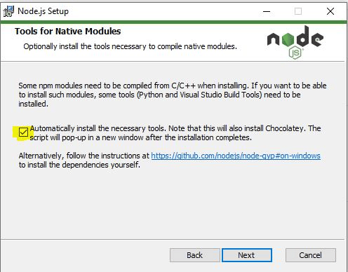

Using Chocolaty for Installation

**Installation Guide**

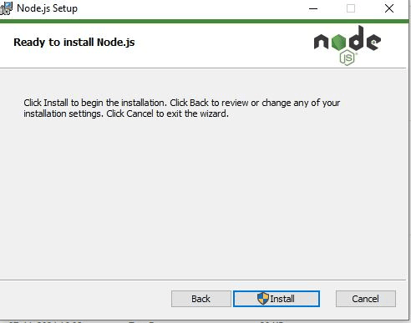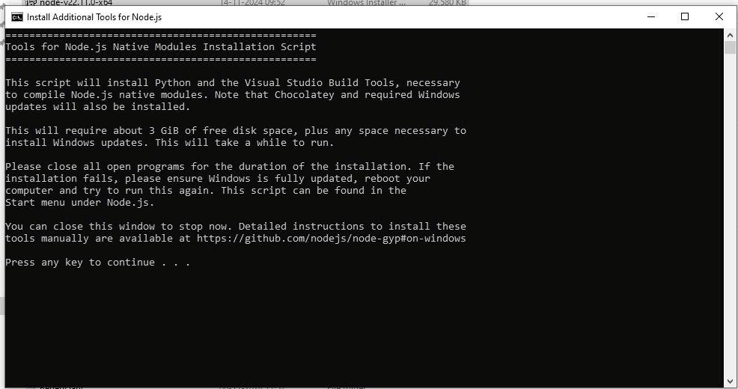

Download the version of VS Code suitable for your operating system.

Node.js Installer Screen

Node.js Shell Verification

**VS Code Installation**

**Installation Guide**

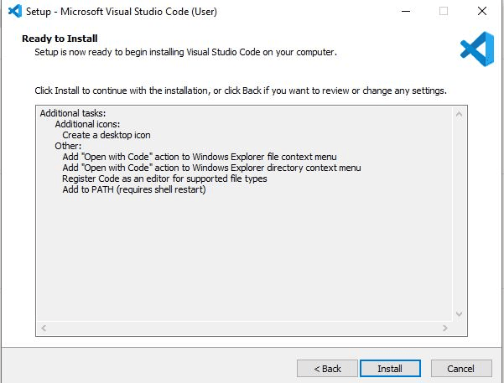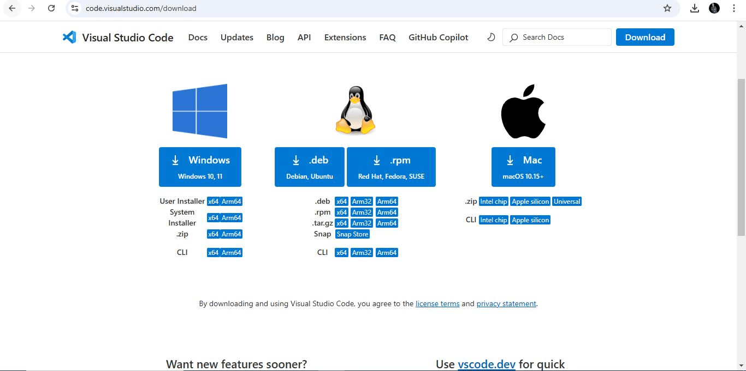

VS Code Installer Screen

VS Code Download Page

Open a folder in VS Code to start working on projects.

Complete the installation and launch the application.

Follow the installer steps to set up VS Code.

**Installation Guide**

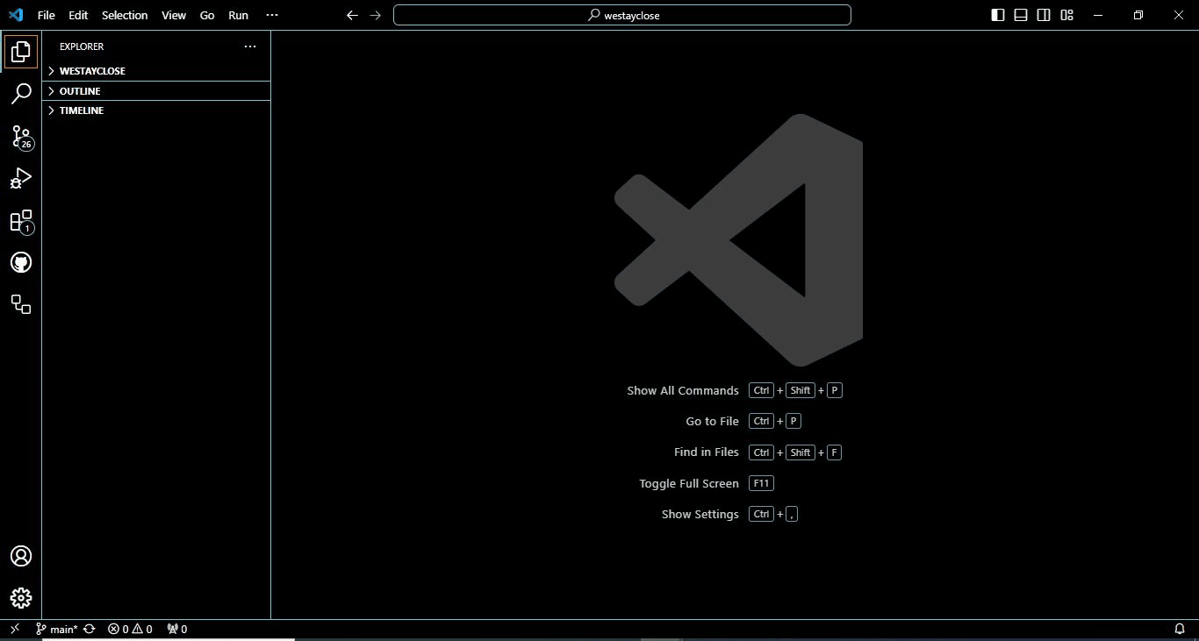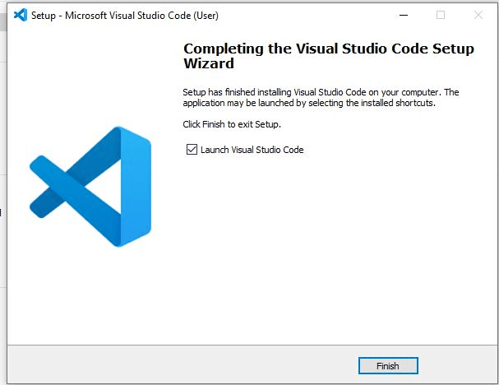

VS Code Installation Complete

Download Spring Tool Suite (STS) from the official site

.

**Installation Guide**

**STS Installation**

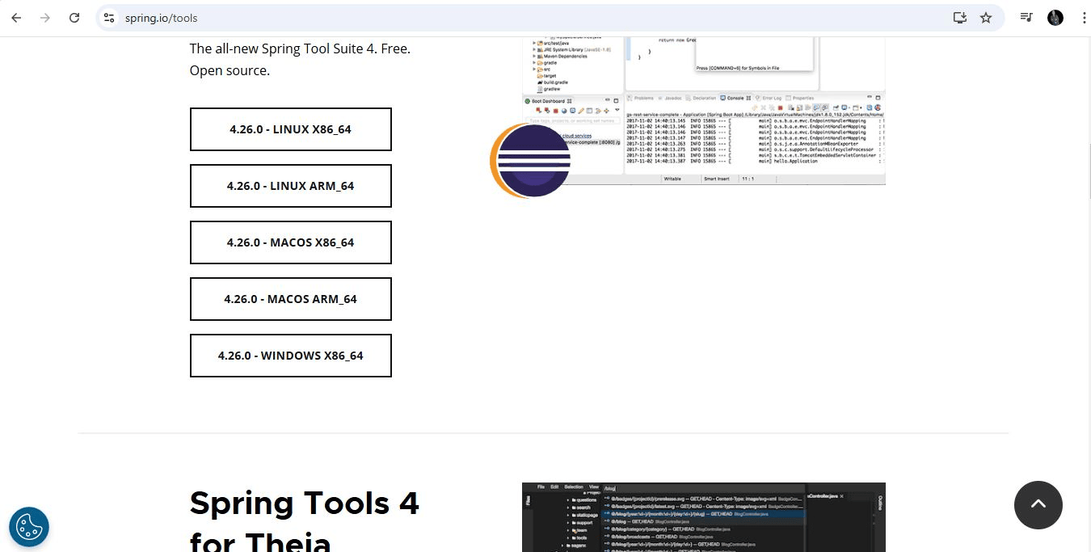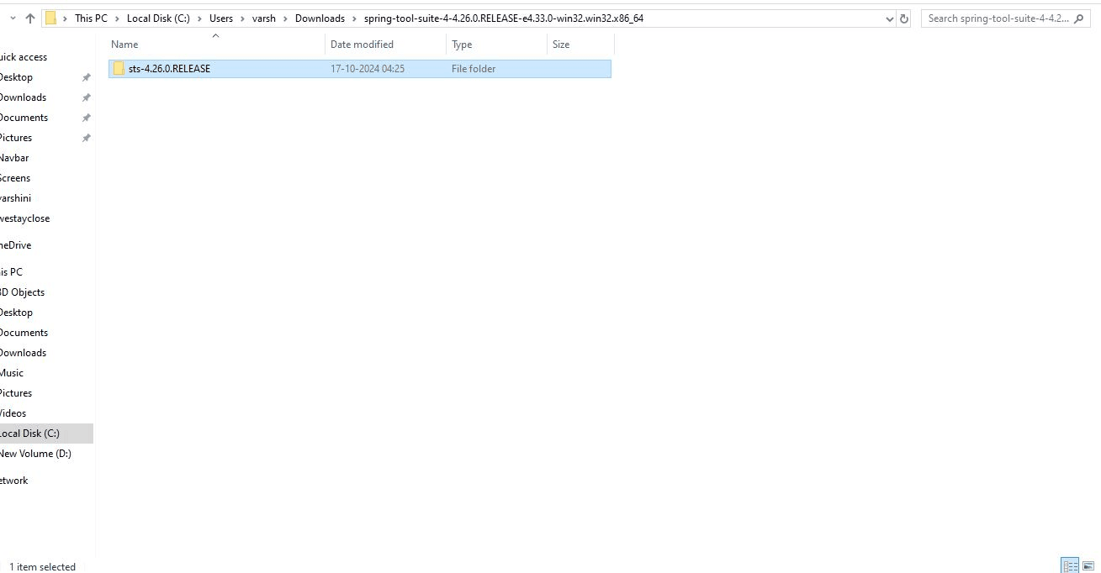

STS Download Page

Extracting STS Archive

Extract the downloaded archive to your desired location.

Start building Spring-based applications.

Launch STS and configure the initial setup.

**Installation Guide**

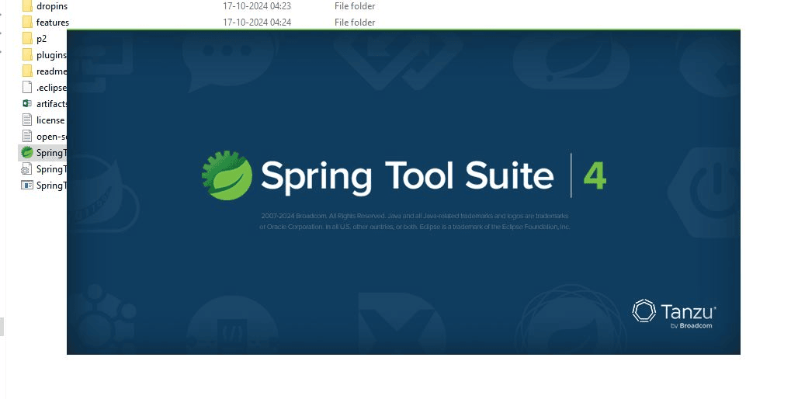

STS Welcome Page

**Installation Guide**

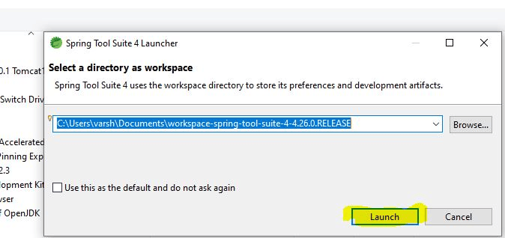

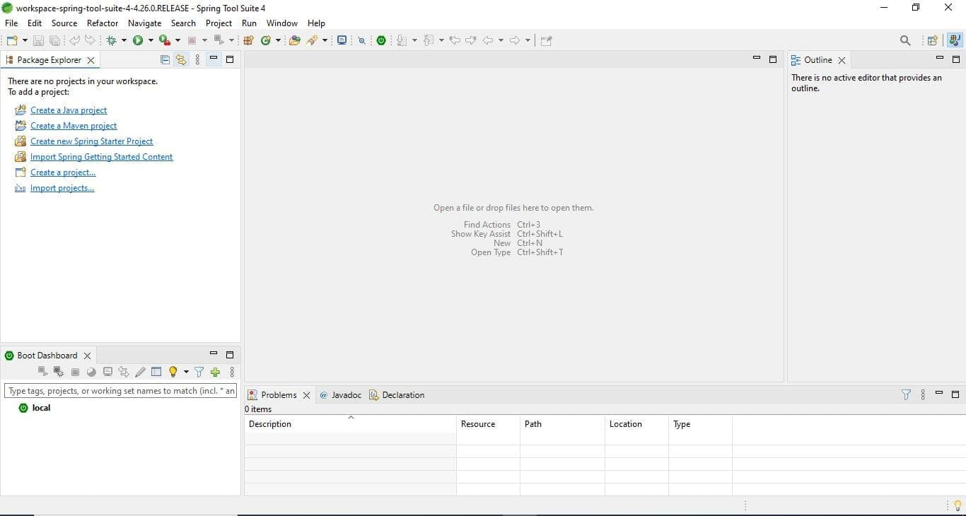

Download MongoDB Community Edition.

**MongoDB Installation**

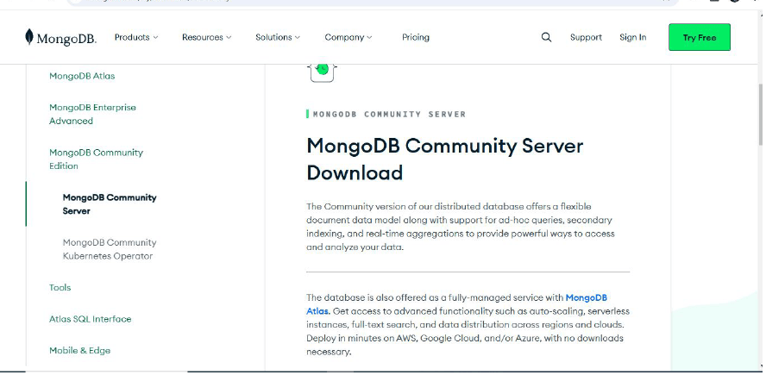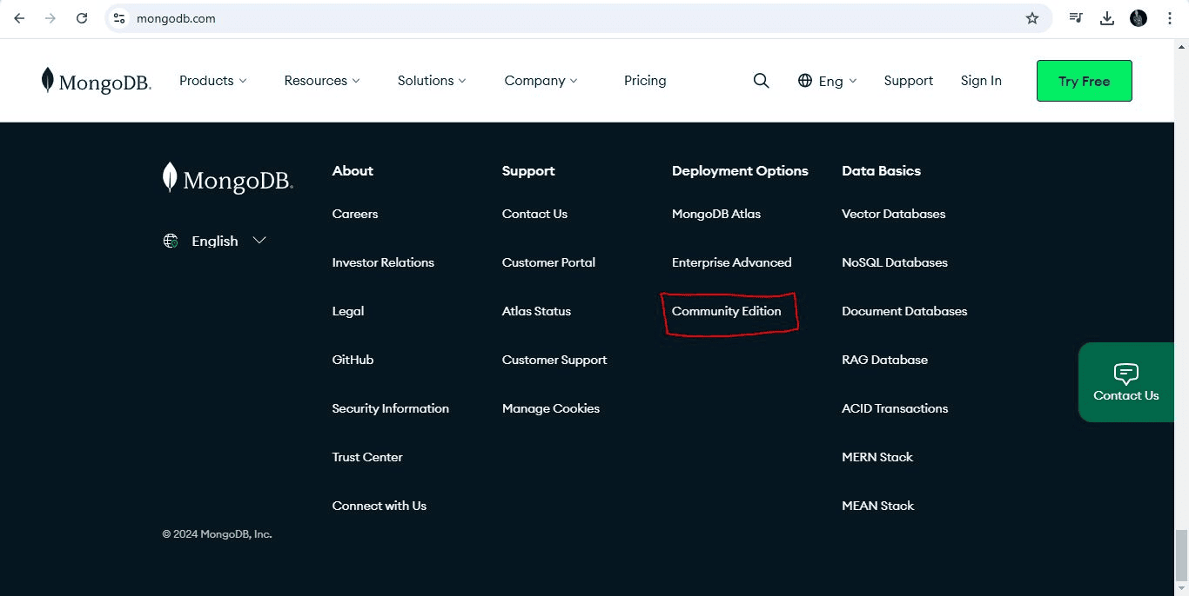

MongoDB Community Edition Download

MongoDB Server Page

**Installation Guide**

Start the MongoDB service and verify the setup.

Follow the installation screens to configure MongoDB.

Select the appropriate setup type and version.

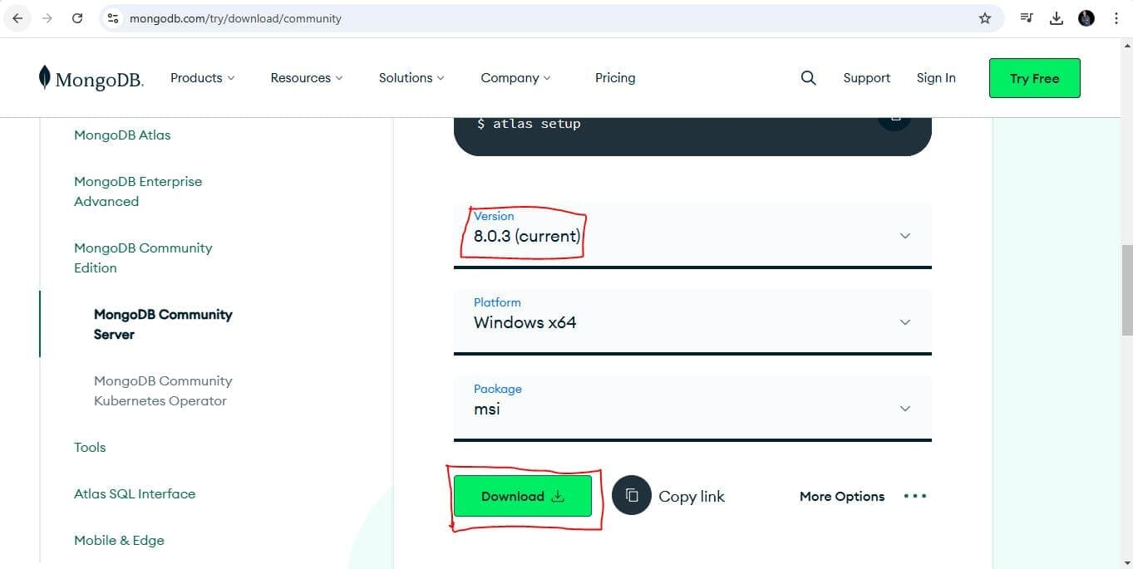

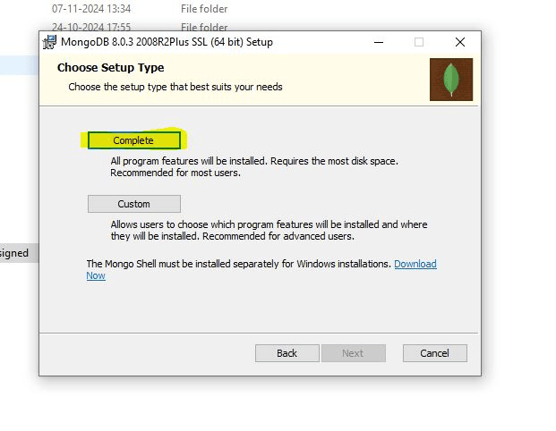 MongoDB version Check

Selecting Setup Type

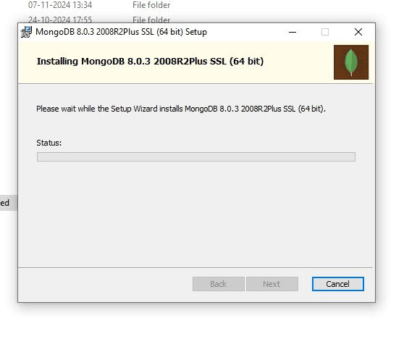

Download the 64-bit version of Git for your OS.

**Git Installation**

MongoDB Installation Screen

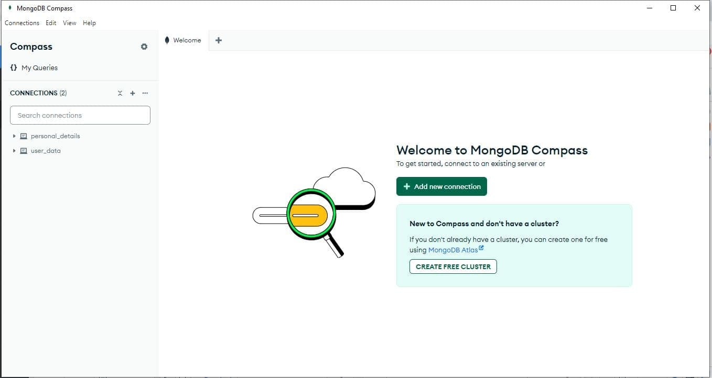

Mongodb screen

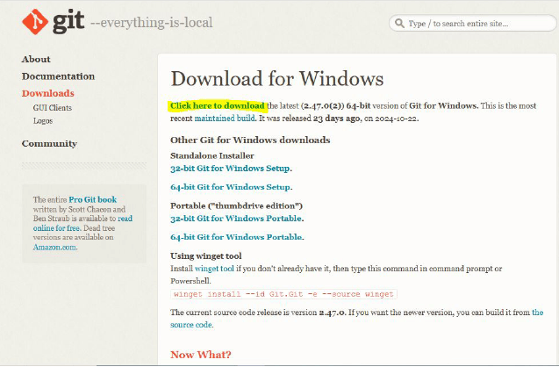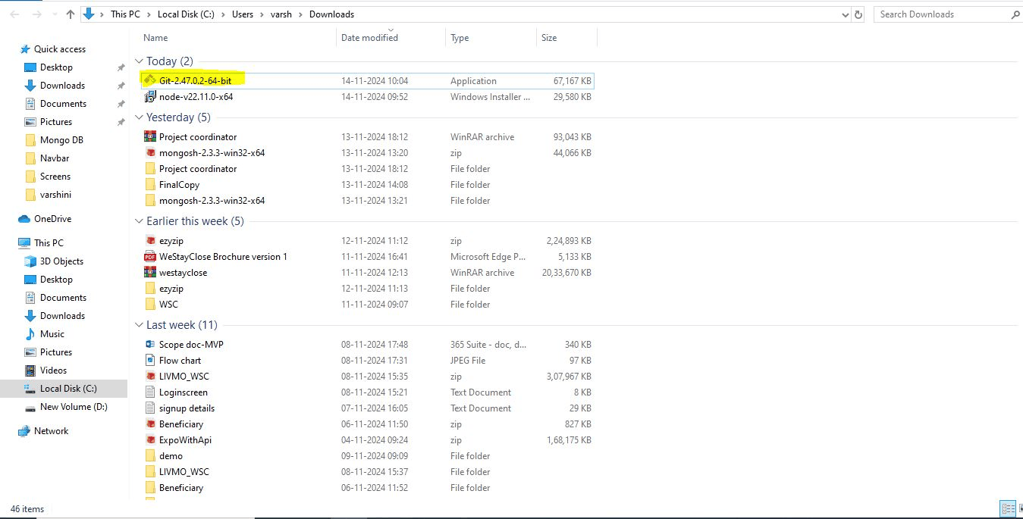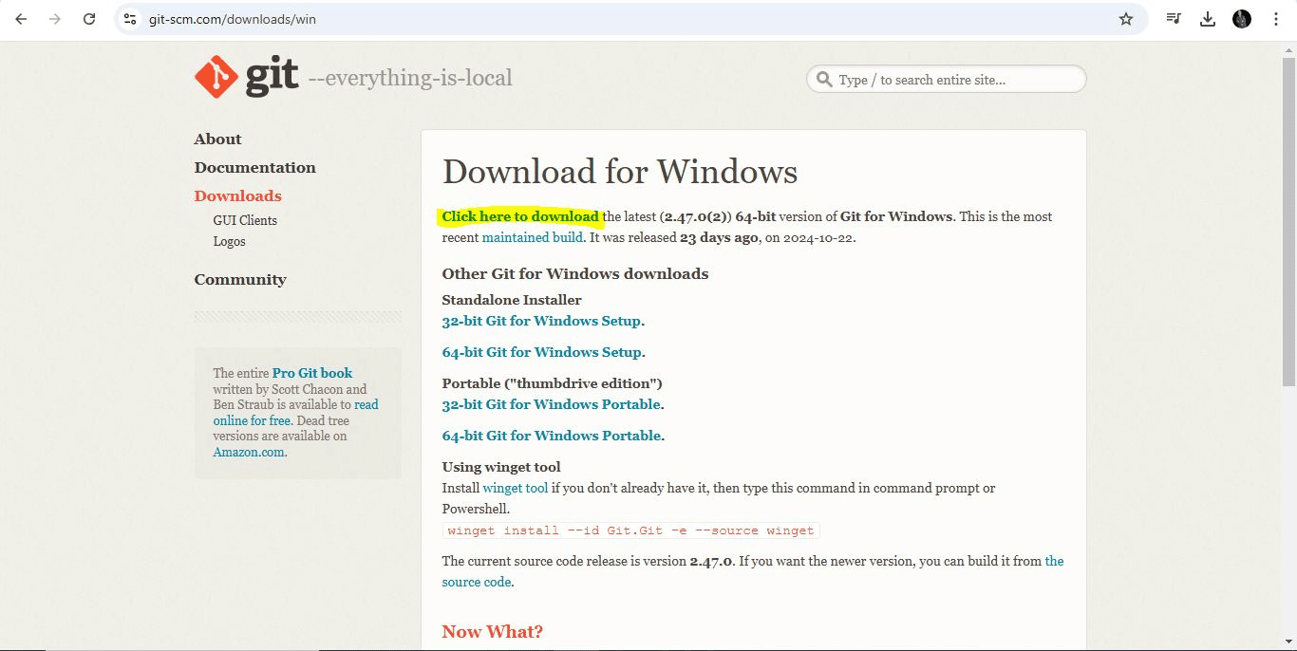

Git Installation Folder

Explore the Git folder and verify the setup.

Proceed through the Git installer screens.

Launch Git Bash to begin using Git.

Downloading Git 64-bit Version

**Installation Guide**

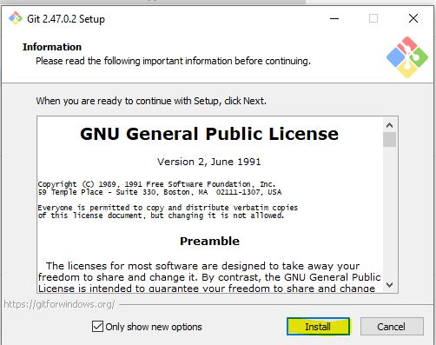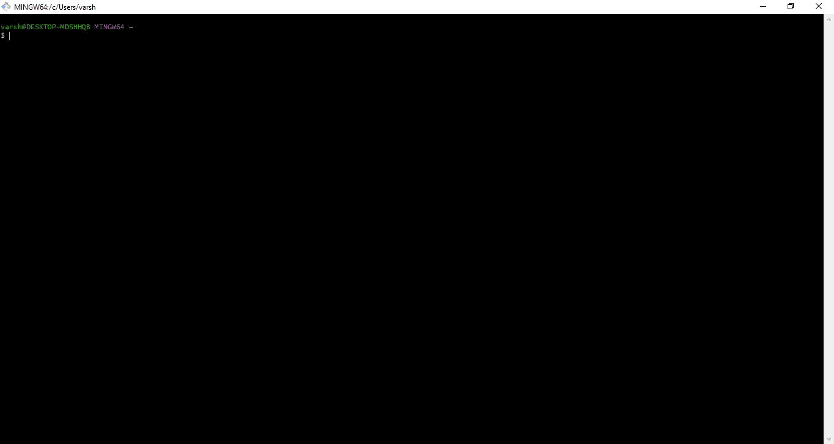

Git Installation Screen

Launching Git Bash

**Installation Guide**

**ANDROID STUDIO INSTALLATION**

Download the "Android studio" from the official website.

Proceed to "Android Studio LadyBug".

After download, follow the installation instructions to install android studio.

Launch the Android Studio.  
  
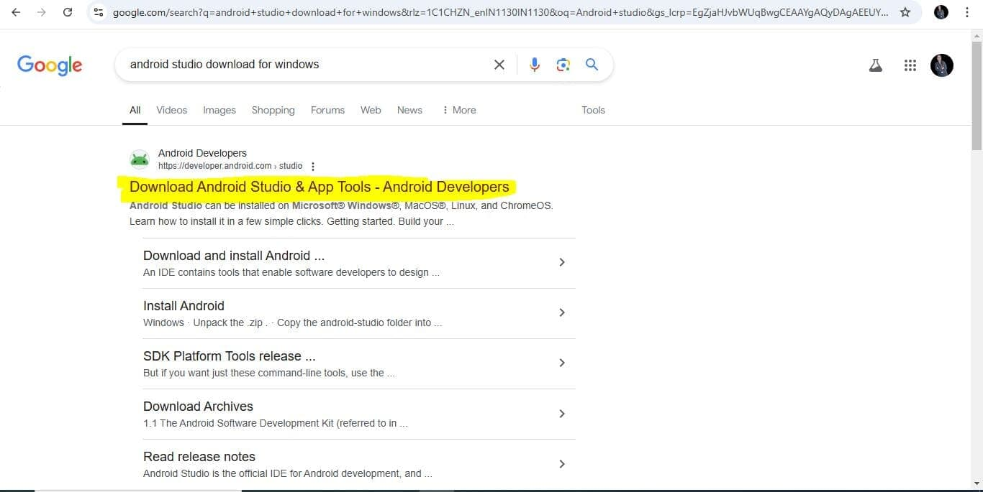

Search box -Android studio  
  
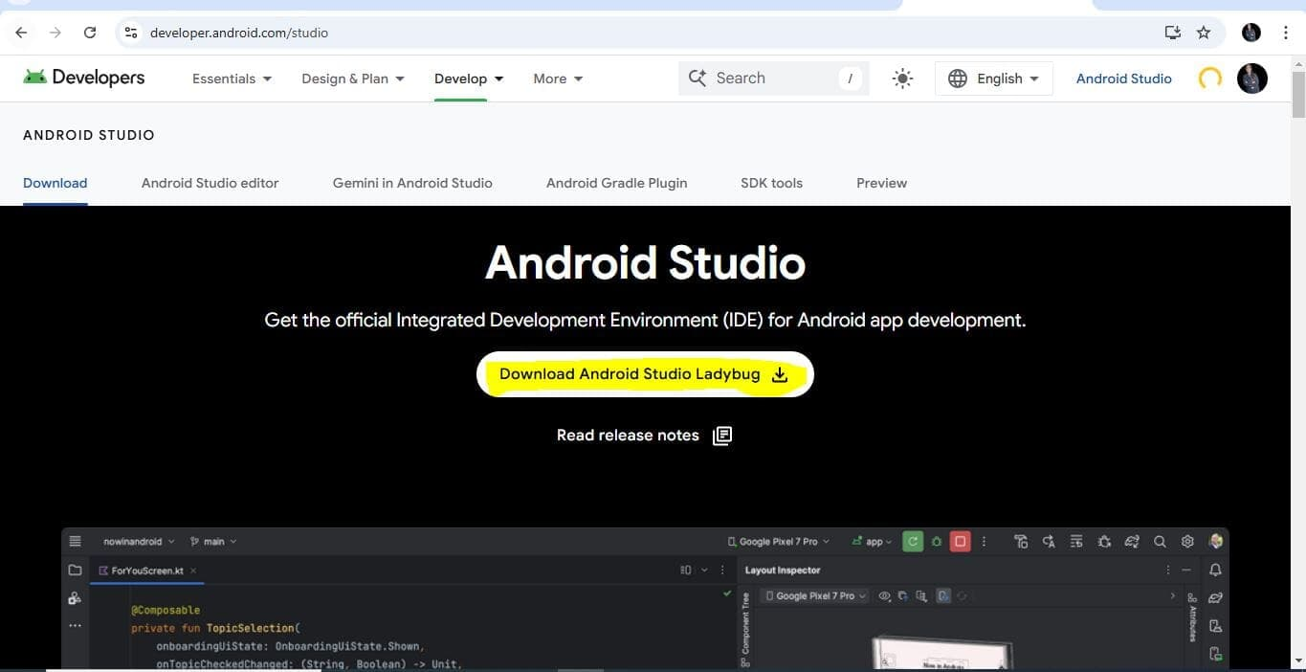

Download Android Studio LadyBug

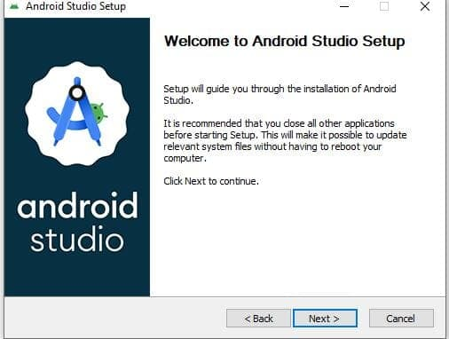

Welcome Screen -Android Studio

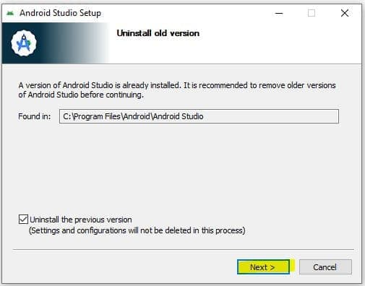

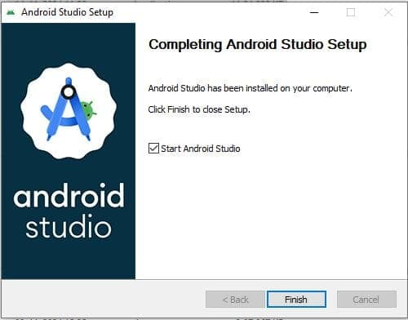

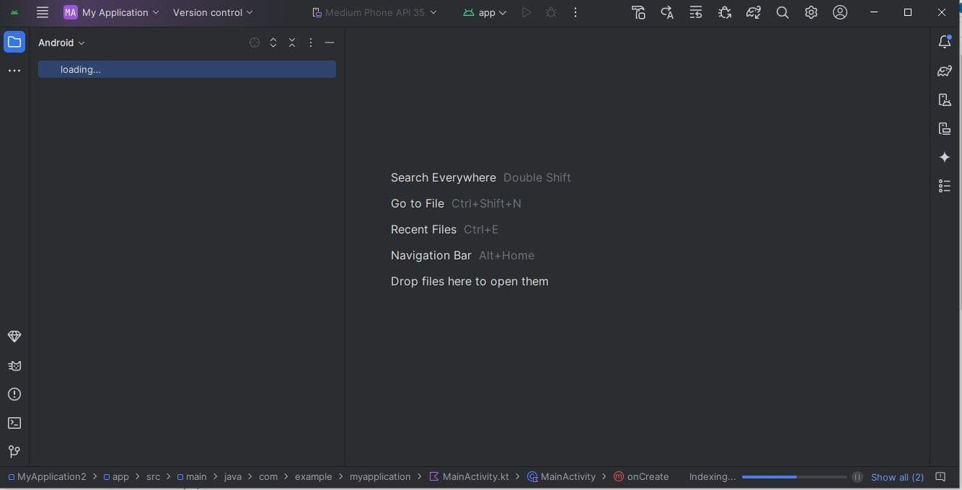

Android Studio Screen